- Do not edit/delete any heading or section with red text.
- Type /paste you answers in relevant sections (below Final Answer (in all questions , Approach (wherever required ) and Charts & tables (wherever required)) of the solution
- Link to submission guidelines
- Please note that submission not following the guidelines will not be accepted

OBJECTIVE QUESTIONS

Question 1: What is the total no. of tables present in the data?

Solution:

Final Answer (if any):
Total number of tables present in the cleaned data: 1

Approach (if any):
If you checked the workbook structure and dataset sheet/dataset, we can find one single consolidated sheet for dataset, hence all records are stored in one sheet so one main table
- All records are stored in a single consolidated dataset
Therefore, counted 1 main table

Charts & Tables (if any):
Table Name: Cleaned Data Table
Description:
A single comprehensive dataset containing all call center records including user details, timestamps, durations, call status, ratings, and other attributes used for analysis.

Question 2: What is the total no. of attributes present in the data?

Solution:

Final Answer (if any):
Total attributes present in the data: 29

Approach (if any):

We can use the formula- =COUNTA(1:1) (if headers are in row 1)
Or
Manually open the sheet and go to the clean dataset and count the total number of the columns(headers)- it is 29

Charts & Tables (if any):
- Table / Chart Name:
<Name of the table or chart used>
- Description:
<What the table or chart represents>

Question 3: The data consists of some inconsistent and missing values so ensure that the data used for further analysis is cleaned.

Solution:

Final Answer (if any):
The dataset has been successfully cleaned and prepared for analysis by removing inconsistencies and handling missing values.

Approach (if any):
The following data cleaning steps were applied:
- Handling Missing Values- identify all missing values in each attribute and identify which suitable values need to be filed.
Like for any amount, number, duration- we used the average to be filled
For any text, string- we used the “no record”, “Missing” value to be enter
I have used if function with the isblank to see if there is any blank value, fill it with the average, others , missing or no records.
- Removing Duplicates
  - Checked duplicate records based on unique identifiers (e.g., ID) and select all data in sheet and click search bar and type remove duplicates based on all column selection
- Standardizing Data Formats
  - Converted date/time fields into a consistent datetime format- like createddate, updatedate , chatstarttime and chatendtime, format all date column in one standard format- using value and substitute function and convert to IST format
=VALUE(SUBSTITUTE(SUBSTITUTE(data!T2,"T"," "), "Z","")) + TIME(5,30,0)
  - Ensured numeric columns (duration, amounts)
- Text Standardization
  - Converted:
    - Names → Proper case - use the proper function to do it
  - Trimmed extra spaces to avoid hidden inconsistencies
- Fixing Inconsistent Values
  - Standardized categorical fields like:
    - CallStatus
    - Region
    - UserCallStatus
  - Removed variations like extra spaces or mismatched capitalization
- Column Structuring
  - Ensured all columns are clearly defined and correctly labeled
  - Verified total attributes (29 columns) are consistent

Charts & Tables (if any):
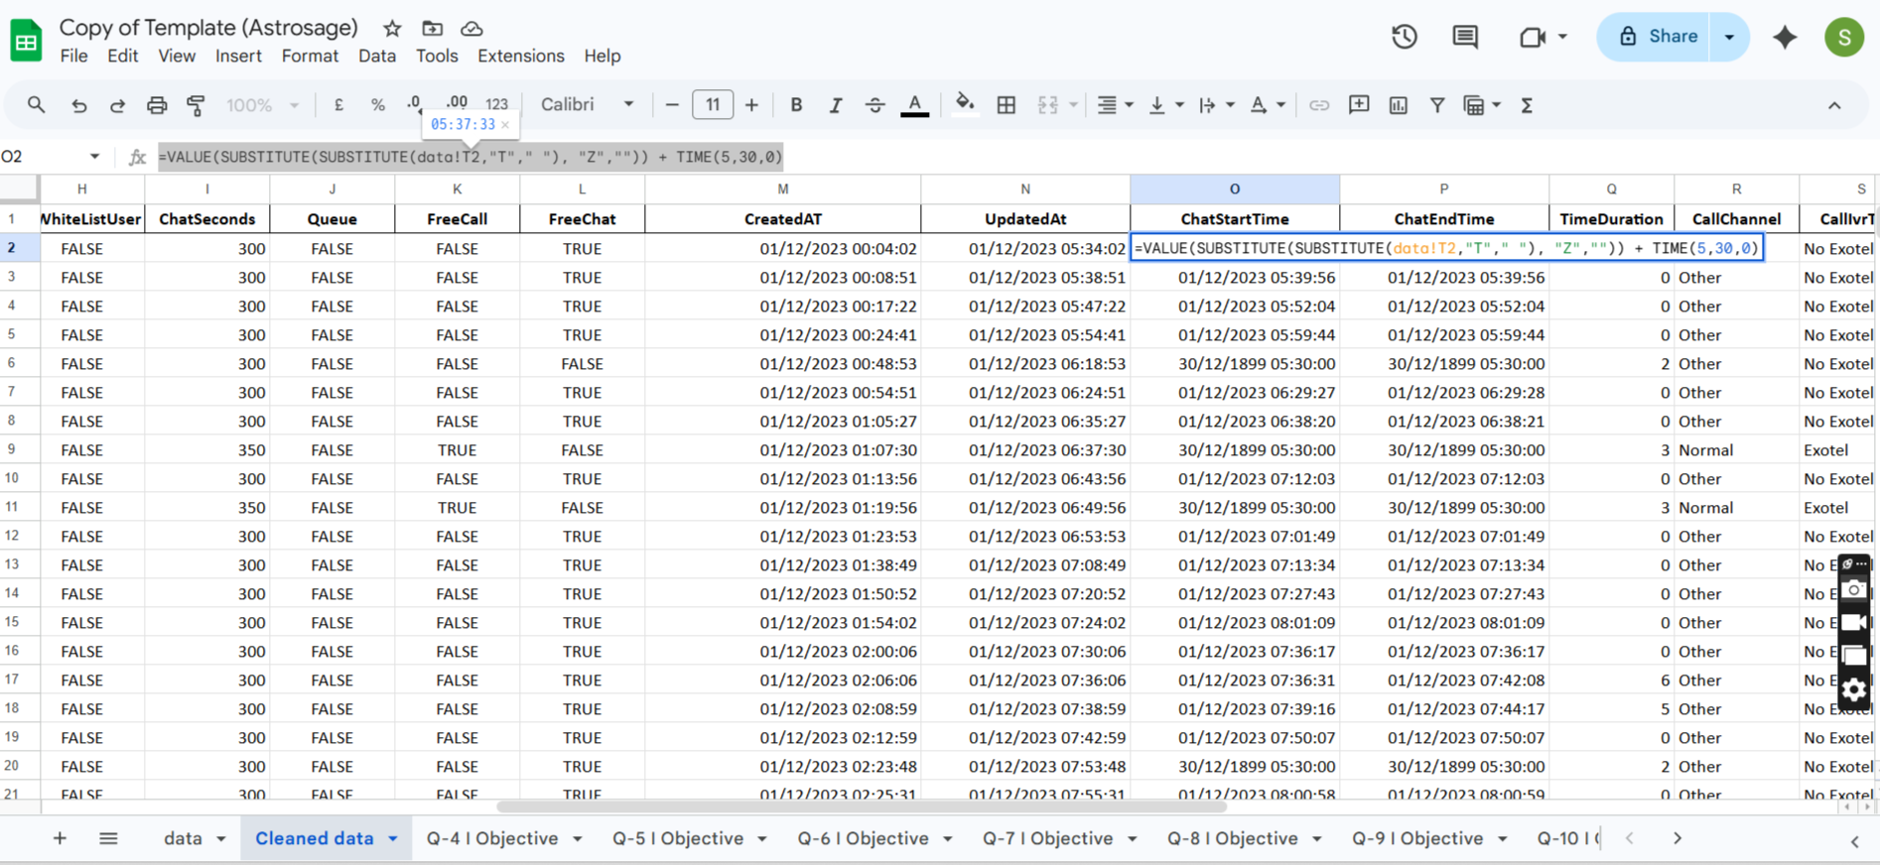

Question 4: What is the change in daily call volume day by day and also find the average daily call volume.

Solution:

Final Answer (if any):
Average Daily Call Volume: 824.32 (rounded to 2 decimal places)
Day-by-Day Change in Call Volume:

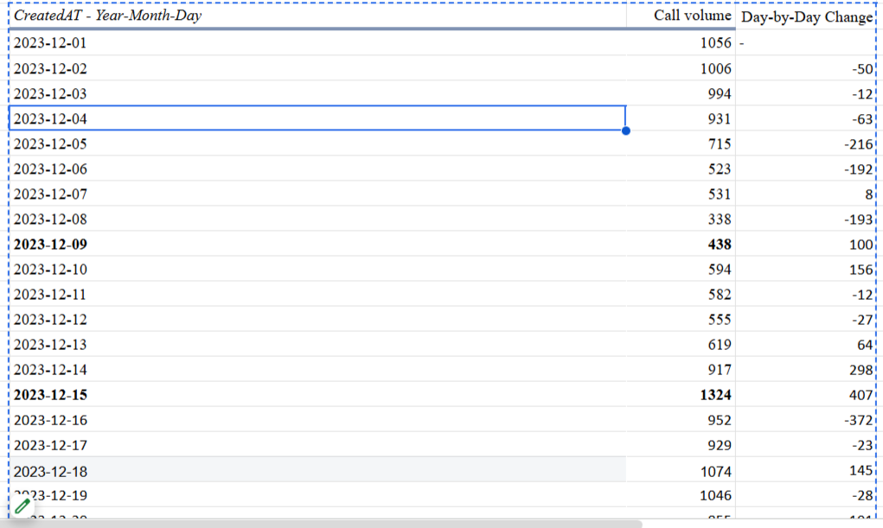

Change in daily call volume is different for each days, we can see in pivot table in attached sheet for objective question 4

Approach (if any):
Created a Pivot Table:
- Rows → Date (CreatedAt grouped by year-month-day)
- Values → Count of Call Id
Calculated Day-by-Day Change:
- Formula used:
=Current Day Calls - Previous Day Calls
Calculated Average Daily Call Volume:
=AVERAGE(Call volume count)

Charts & Tables (if any):

Table Name: Daily Call Volume Analysis
Description:
Shows the number of calls received each day along with the increase or decrease compared to the previous day, helping identify trends and fluctuations in call traffic.

Call volume shows a declining trend initially, followed by a sharp increase after Dec 9, peaking on Dec 15 (1324 calls)

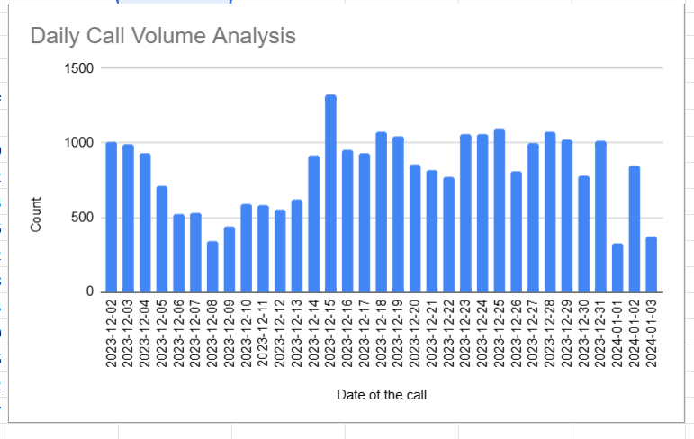

Question 5: Which months experienced the highest and lowest call volumes?

Solution:

Final Answer (if any):
Highest call volume- December
Lowest call volume- Jan

Approach (if any):
Created a Pivot Table:
- Rows → Date (CreatedAt grouped by year-month)
- Values → Count of Call Id
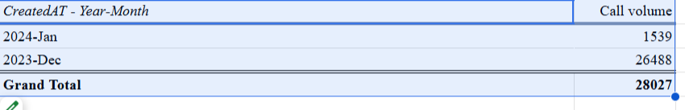

Charts & Tables (if any):
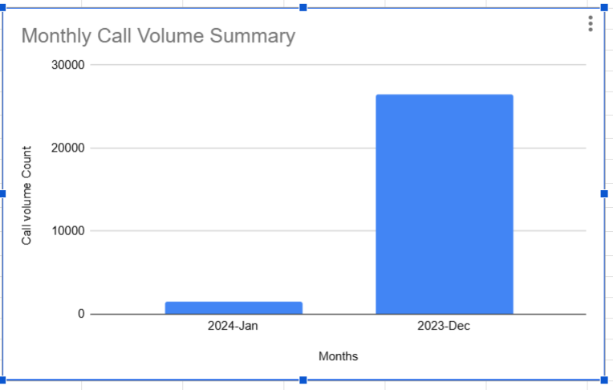

Question 6: What is the total operational cost for that month?

Solution:

Final Answer (if any):

CreatedAT - Year-Month | SUM of Operational Cost
2023-Dec | 400320
2024-Jan | 23378

Approach (if any):
Using Pivot Table (Recommended)
- Rows → Created At (year-month wise)
- Values → Sum of Net Amount

Charts & Tables (if any):
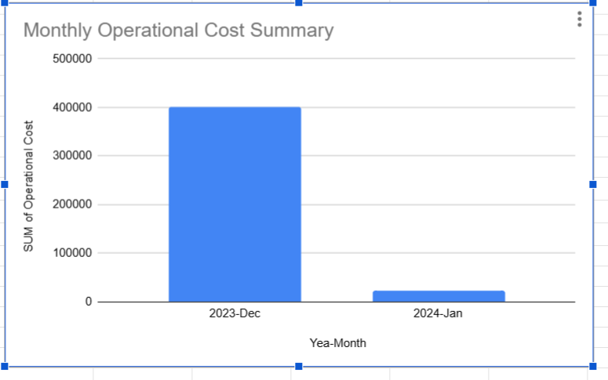

Question 7: What is the average number of calls handled per agent per day?

Solution:

Final Answer (if any):
Average number of call handled by per agent per day is approx = 246.0294118

Approach (if any):

Create Pivot Table
- Rows → GuruName
- Columns → createdAT
- Values → Count of Call SID

Charts & Tables (if any):

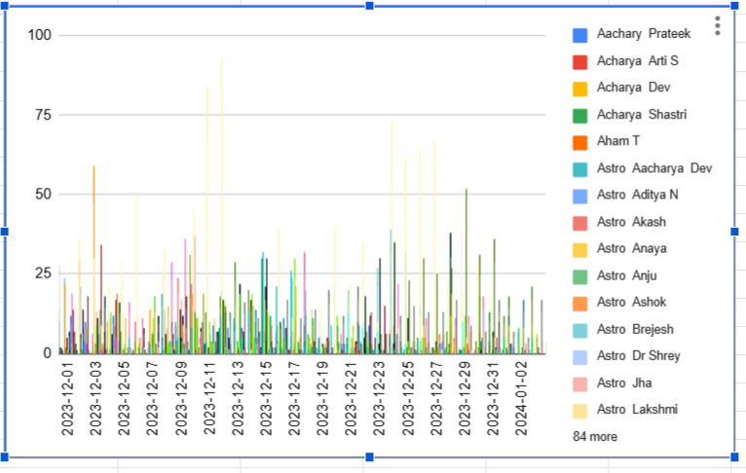

Question 8: How many repeat callers are there, and what percentage of total calls do they represent?

Solution:

Final Answer (if any):
1275 are repeat caller

Approach (if any):
Create a pivot table
Add userid is rows
Add callSid in value and apply a filter which has count more than 1 which means those userid are not repeated callers.
Add count of call SID in values
And filter the callsid which dont have any callsid

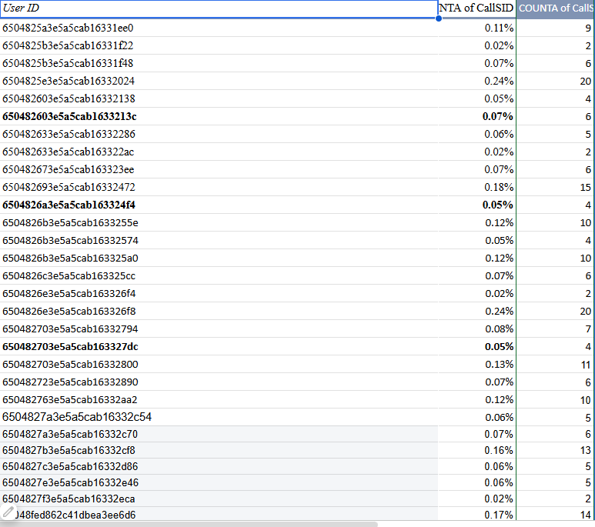

Charts & Tables (if any):

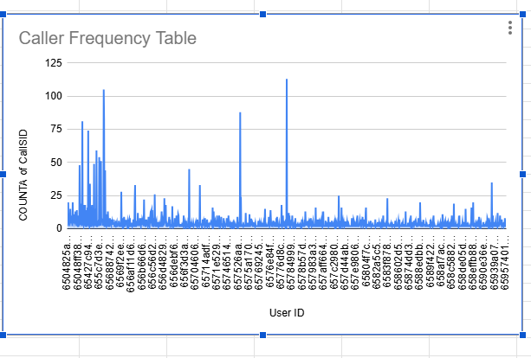

Question 9: What are the total sales generated by the call centre for each product category?

Solution:

Final Answer (if any):
Not applicable / Cannot be determined from the dataset

Approach (if any):
- Reviewed the Cleaned Data sheet
- Checked for columns related to:
  - Product Category- there is no any information about the product in dataset hence it cant be calculated
- The dataset primarily contains:
  - Call details (timestamps, duration, status, agent, etc.)
  - Operational metrics (calls, ratings, durations)
No product-related or sales-related fields are present
Therefore, sales by product category cannot be calculated

Charts & Tables (if any):
Table Name: N/A
Description:
The dataset does not include product or sales information, so no table or chart can be generated for this question.

Question 10: How many calls were made for each user ID and guru ID?

Solution:

Final Answer (if any):
Number of calls were made for each guid and userid is mentioned in pivot table

Approach (if any):

Create Pivot Table
- Rows → User ID
- Rows→ Guru ID
- Values → Count of Call ID

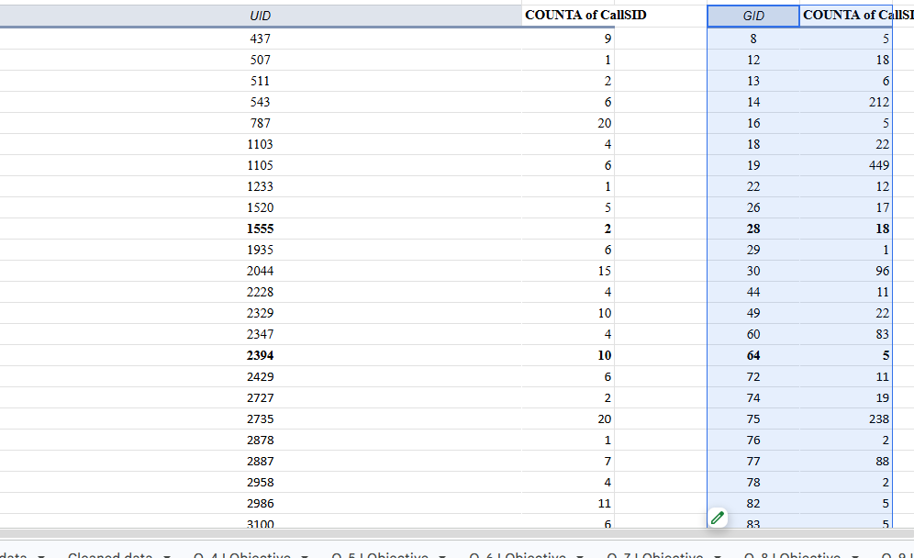

Charts & Tables (if any):

Displays the number of calls made by each user to each guru, helping analyze interaction patterns between users and service providers.

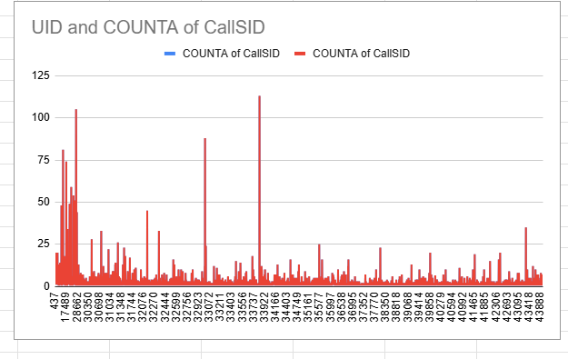

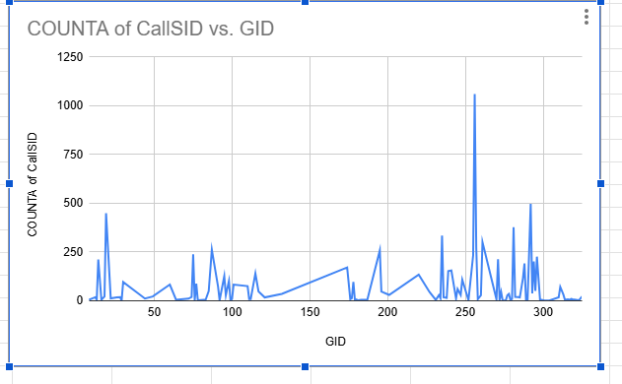

Question 11: What is the correlation between call duration and customer satisfaction?

Solution:

Final Answer (if any):

Correlation = 0 (No correlation)

Approach (if any):
Correlation measures how two variables change together.
But here:
- Duration is constant (no variation)
- Rating is changing
When one variable does not change at all, correlation cannot exist.
As you can see below there is no constant in rating columns so two variables are changing we cant draw a corelation between these 2 varaibles
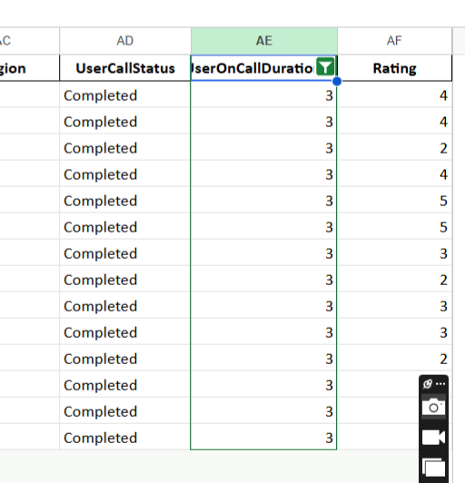

Charts & Tables (if any):
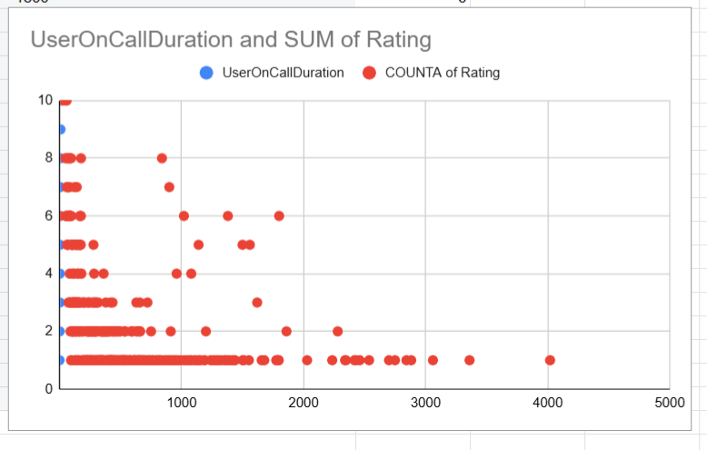

Question 12: Which guru has the highest and lowest customer satisfaction scores?

Solution:

Final Answer (if any):

Tarot Rittika has lowest customer satisfaction rating
Astro Pujaa Rai and Tarot Mystical has highest customer satisfaction rating

Approach (if any):

Create Pivot Table
- Rows → Guru ID / Guru Name
- Values → Rating
  - Change to Average
This gives average satisfaction score per guru name

Charts & Tables (if any):
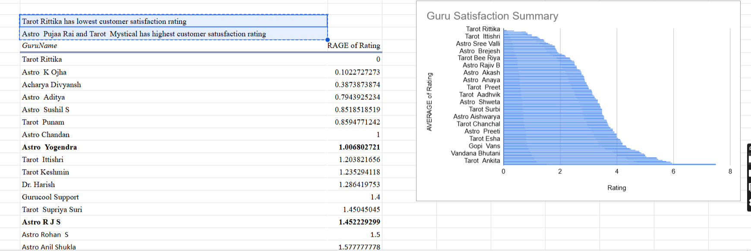

Question 13: What is the average customer satisfaction score by month?

Solution:

Final Answer (if any):

CreatedAT - Year-Month | AVERAGE of Rating
2023-Dec | 2.949637572
2024-Jan | 2.676413255

Approach (if any):

Create Pivot Table
- Rows → Month (from CreatedAt)
- Values → Rating
  - Set to Average

Charts & Tables (if any):
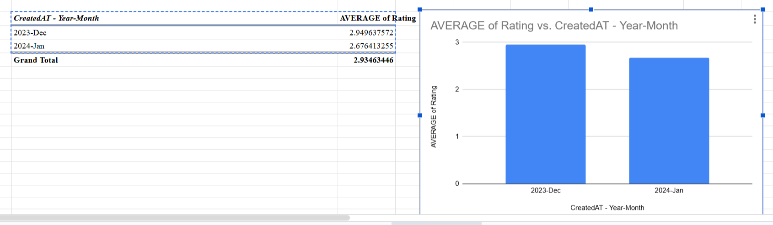

Question 14: How many categorical columns are there in the data? [Search about categorical and continuous data, and try to answer this question]

Solution:

Final Answer (if any):
Total number of categorical columns in the dataset: 11

Approach (if any):

Categorical Data (Qualitative):
Represents labels, groups, or categories
Examples: UserID, GuruID, Region, Status

Continuous Data (Quantitative):
Numeric values that can be measured
Examples: Duration, Rating, Cost

the following are categorical:

UserID

GuruID

CallStatus

UserCallStatus

Region

Category / Consultation Type

Rating

Month / Day -createdAT

CallSId
- Call status
- callchannel

Charts & Tables (if any):

SUBJECTIVE QUESTIONS

Question 1: Should the investment be used to hire more agents, improve training programs, or upgrade call center technology?

Solution:

Approach:
The investment should be primarily used to improve training programs, with partial allocation toward hiring agents.

Analyzed key performance metrics from dataset:
- Daily call volume trends
- Average customer satisfaction (ratings)
- Call handling patterns (per agent, per day)
Assumptions:
- High call volume = workload pressure
- Low/average ratings = quality issue
- Balanced calls but poor ratings = training gap
Methodology:
- Used Pivot Tables to:
  - Track daily call trends
  - Evaluate average ratings
  - Analyze agent performance

Charts & Tables:
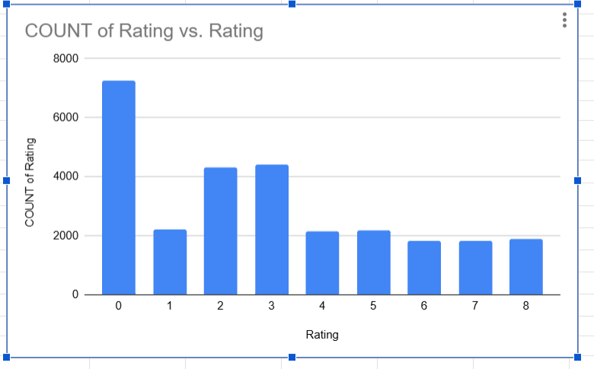

Customer Satisfaction Summary
Description: Shows overall average rating

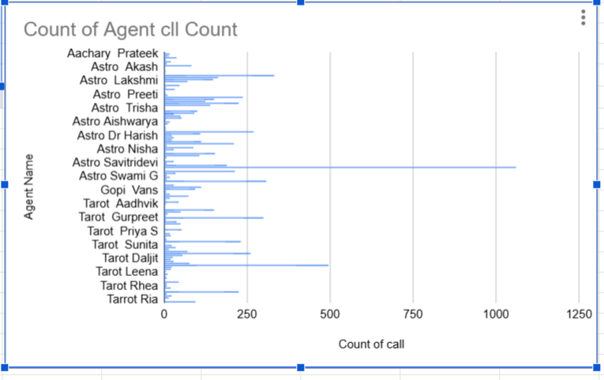

Agent Performance Table

Displays number of calls handled and average ratings per agent

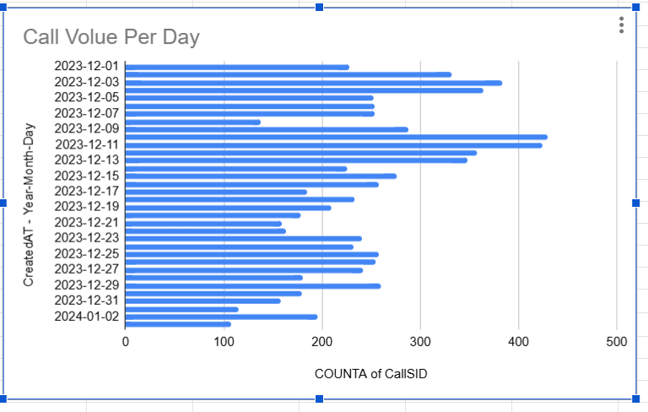

Daily Call Volume Trend (Pivot Chart)
Shows fluctuations in call volume across days

Insights:

- Call volume shows fluctuations with peak days, but not consistently overwhelming
- Customer satisfaction is moderate (not very high)
- Some agents likely perform better than others (variation expected)
- No strong evidence that system/technology is failing
- Main issue appears to be service quality, not capacity or system failure

Recommendations:
The analysis indicates that improving agent training will have the highest impact on customer satisfaction, while selective hiring can help manage workload during peak periods. Technology upgrades are not the immediate priority

Question 2: What are the potential risks of each investment option (hiring, training, technology upgrades), and how can they be mitigated?

Name the chart/spreadsheet function you will use for solving the problem.

Solution:

Approach:
- Daily call volume trends
- Average ratings (customer satisfaction)
- Call status distribution
Mapped insights to risks:
- High variation in call volume → hiring risk
- Moderate ratings → training required for agent who has less call received
Evaluated impact vs cost
- Training → high impact, moderate cost
- Hiring → moderate impact, high cost
- Technology → long-term impact, high cost

Potential Risks & Mitigation

Risk involve in hiring more agents are -
- It will increase the cost of operation
- Those agent will not utilized during the low call volume
- Training required for those agent which will time consuming
Mitigation plan involve for those:
- Hire experience agent during the pick time
- Use part-time / shift-based staffing
- Combine with training program
Risks involved in training program are :
- Initial time investment (agents unavailable during training)
- No immediate visible results
- Cost of training programs
Mitigation:
- Implement phased training (batch-wise)
- Track improvement using based on rating provided to agent
- Focus on low-performing agent
Risks involved in Upgrade call center technology:
- High upfront cost
- Implementation challenges
- Learning curve for agents
- Possible downtime during transition
Mitigation:
- Upgrade in phases (not full replacement)
- Provide technical training to agents
- Pilot testing before full rollout

Charts & Tables:
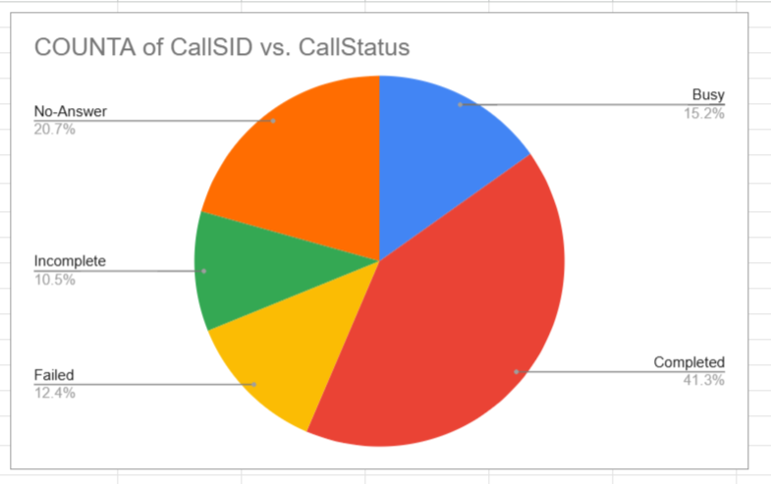
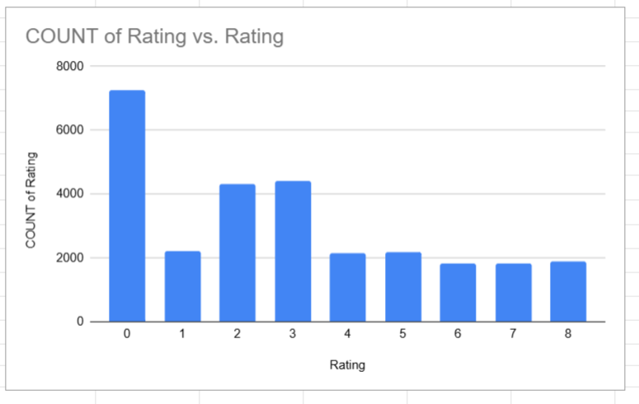
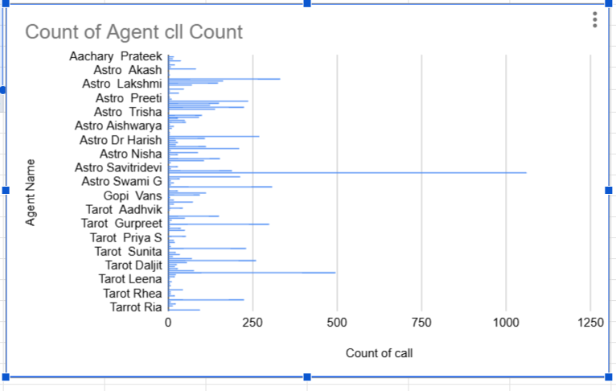

Insights:

Call volume is not consistently high, so full-scale hiring is risky
Customer satisfaction is moderate, indicating training gap
No strong evidence of system failure → tech upgrade not urgent

Recommendations:

Primary recommendation is - Invest in Training Programs which is likely improve the customer satisfaction and enhance agent performance and secondary recommendation is to hire more agents. And technology upgrade is very low priority as data has never shown any records about system failure.

Training provides the highest return with manageable risk, while hiring should be demand-driven and technology upgrades should be phased to minimize financial and operational risks

Question 3: How does AstroSage's call center performance compare to AstroGuru's average call volume, customer satisfaction, and agent performance?

Will you use any aggregation function or a visualization here to solve the problem?

Solution:

Approach:
<Reasoning, assumptions, and methodology used to solve the problem>

Charts & Tables:
- Table / Chart Name:
<Name of the table or chart used (should align with Excel subsheet names) along with the screenshot of chart or table>
- Description:
<What the table or chart represents>

Insights:
<Key observations derived from the data>

Recommendations:
<Actionable recommendations based on the insights>

Question 4: How can the call center improve its handling of peak call periods to ensure high customer satisfaction?

Mention the functionality you will use for giving the suggestions, will it be any aggregated function or a visualization?

Solution:

Approach:
- Created daily call volume trend- help to identify the high demand days
=COUNT(Callsid)

Customer satisfaction rating- compare rating during high vs low call days
=AVERAGE(Rating)
Calls per agent using:
=COUNTIFS(GUID, CallSid)

Charts & Tables:
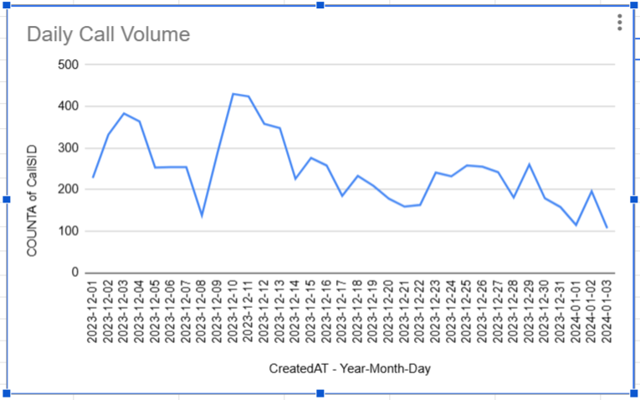

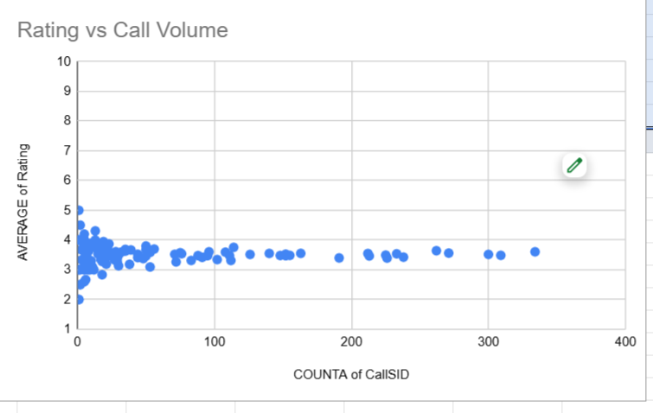
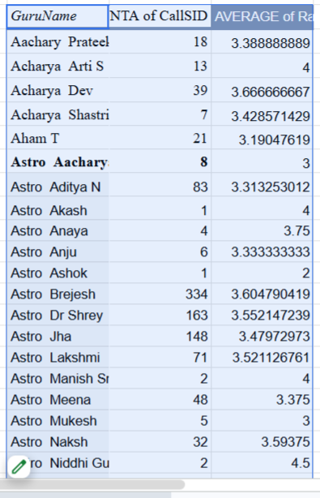

Insights:
Call volume shows clear peak periods (high fluctuation)
During peak days:
- Agents likely face higher workload
- Customer satisfaction may drop slightly
Workload distribution is not always balanced

Recommendations:
Dynamic Agent Scheduling
- Increase agents during peak hours/days
- Use historical data for forecasting

Improve Training for Peak Handling
  - Faster issue resolution
  - Handling high-pressure situations
Workload Balancing
  - Distribute calls evenly across agents
  - Avoid agent burnout
Monitor Real-Time Performance
  - Call volume
  - Wait time
  - Satisfaction

Question 5: Based on historical data, what strategic initiatives should be prioritized to improve efficiency and customer satisfaction?

Solution:

Approach:

Analyze Historical Trends
Used:
- Daily call volume (COUNT)
- Customer satisfaction (AVERAGE Rating)
- Agent performance (calls handled per agent)

Identify Patterns
- Peak vs low call days
- Variation in customer satisfaction
- Differences in agent performance

Tools & Functions Used
✔ Aggregation Functions:
COUNT() → Total calls
AVERAGE() → Customer satisfaction
COUNTIFS() → Calls per agent

Charts & Tables:
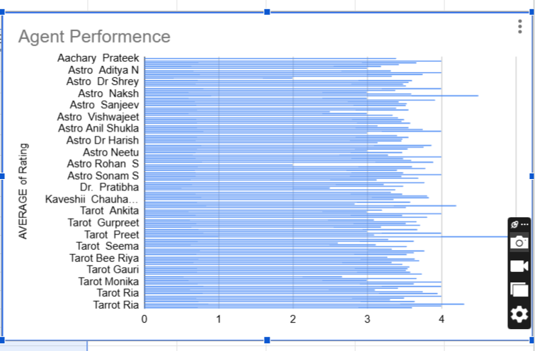
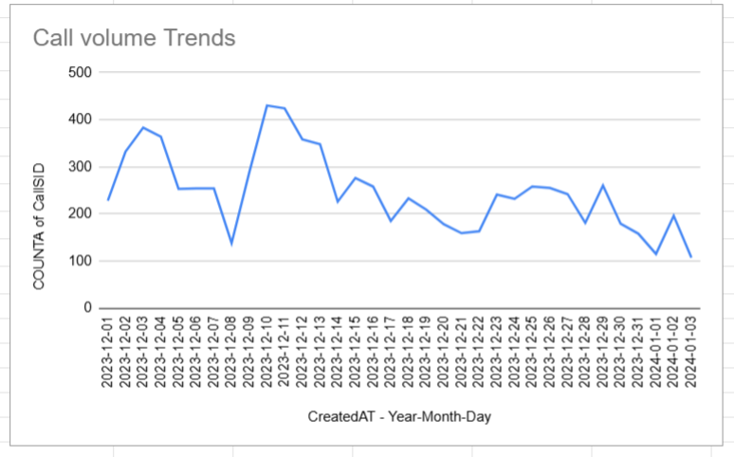

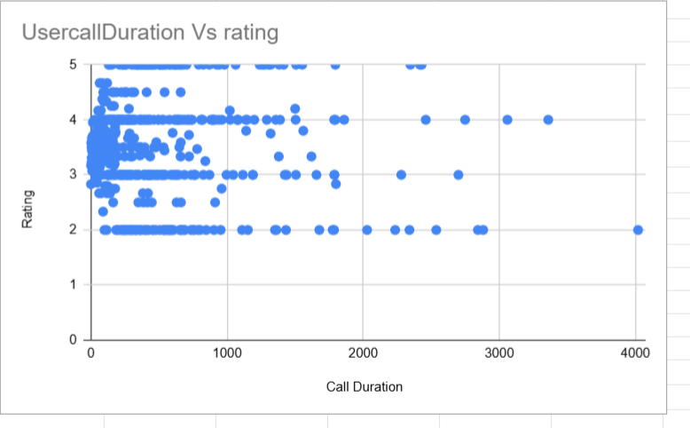

Insights:
Call volume shows significant fluctuations → need flexible staffing
Customer satisfaction is moderate (not very high) → improvement needed
Agent workload is uneven → inefficiency in allocation
No strong correlation between duration and satisfaction → quality matters more

Recommendations:
Prioritize Training Programs (High Impact)
- Improve: communication skills and Issue resolution time
- Result → Higher customer satisfaction

Implement Smart Staffing Strategy
- Increase agents during peak periods
- Reduce idle time during low demand

Balance Workload
- Distribute calls evenly
- Monitor agent performance regularly

Improve Call Handling Efficiency
- Reduce unnecessary call duration
- Focus on first-call resolution

Question 6: What can be the key factors contributing to high customer satisfaction scores, and how can these be leveraged to improve overall performance?

What is the basis for the suggestions? And mention how you decided if the satisfaction score affects the ratings.

Solution:

Approach:

Analyze Customer Satisfaction (Ratings)
=AVERAGE(Rating)
And compare against to each Guru
Create a pivot table to analyze the trand
  - Rows → Agent / Guru ID
  - Values → Average Rating
This will give us information which against is high performing and which is low performing

Analyze Workload vs Satisfaction
How many call are received per agents
=COUNTIFS(GuruID/name, CallSid)
Check if overloaded agents have lower ratings

Check Duration vs Satisfaction
Used correlation:
=CORREL(usercallduration, Rating)
- No strong correlation (very weak / zero)

Charts & Tables:

Visualization Used
- Scatter Plot → Duration vs Rating
- Bar Chart → Agent vs Avg Rating
- Line Chart → Rating trend
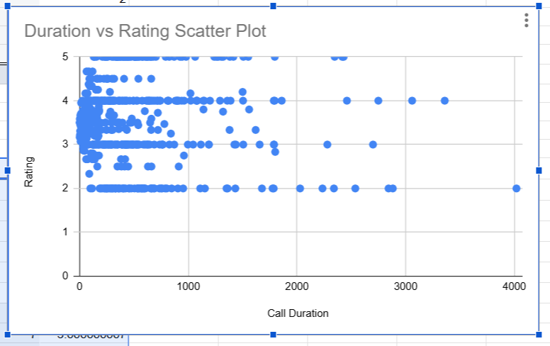

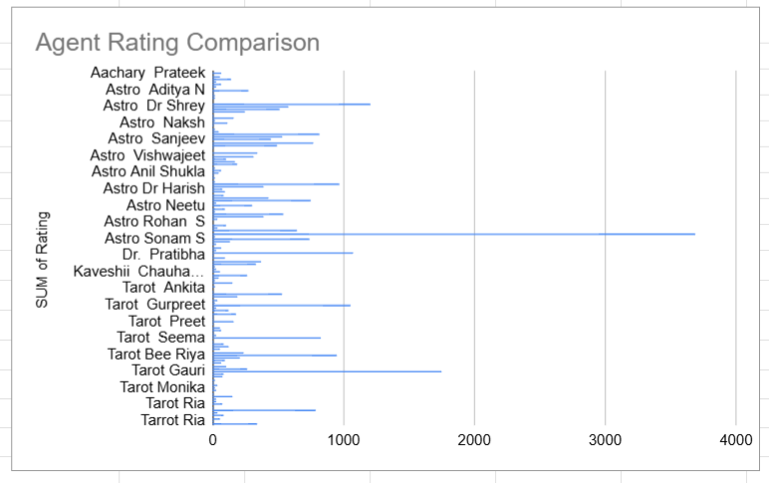

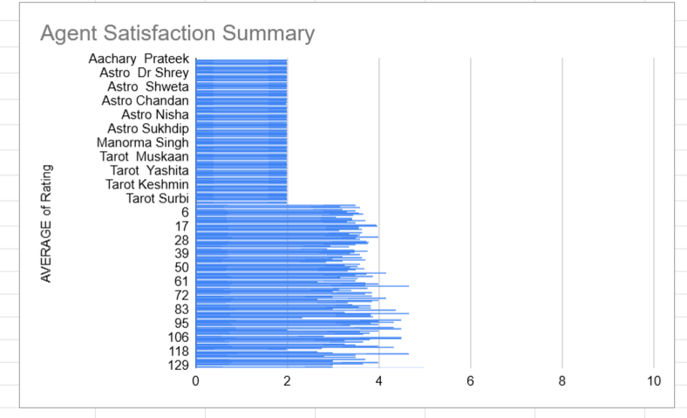

Insights:
High satisfaction is linked to agent quality, not call duration
Some agents consistently deliver better ratings
Overloaded agents may have slightly lower satisfaction
Duration has little to no impact on ratings

Recommendations:

Focus on High-Performing Agents
- Identify top agents
- Use them for training others

Improve Training Programs
- Focus on:
  - Communication
  - Problem-solving

Balance Workload
- Avoid overloading agents
- Ensure fair distribution

Optimize Call Quality, Not Length
- Don’t aim for longer calls
- Focus on effective resolution

Question 7: How should the call center balance the workload among agents to ensure optimal performance and avoid burnout?

Mention your approach and spreadsheet function for the answer.

Solution:

Approach:

Measure Workload per Agent- Calculates number of calls handled by each agent
=COUNTIFS(GuruName, CallSid)

Calculate Average Workload- Defines ideal workload per agent
=AVERAGE(Count of callSid)

Identify Imbalance- High deviation = uneven workload distribution
=STDEV.P(callSid)

Compare with Performance
- Combined:
  - Calls handled and Avergae rating

Charts & Tables:

Visualization
- Bar chart → Calls per agent
- Call duration vs Agent performance
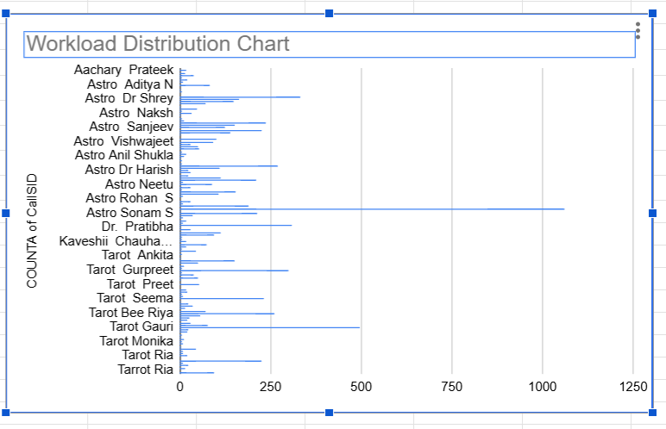

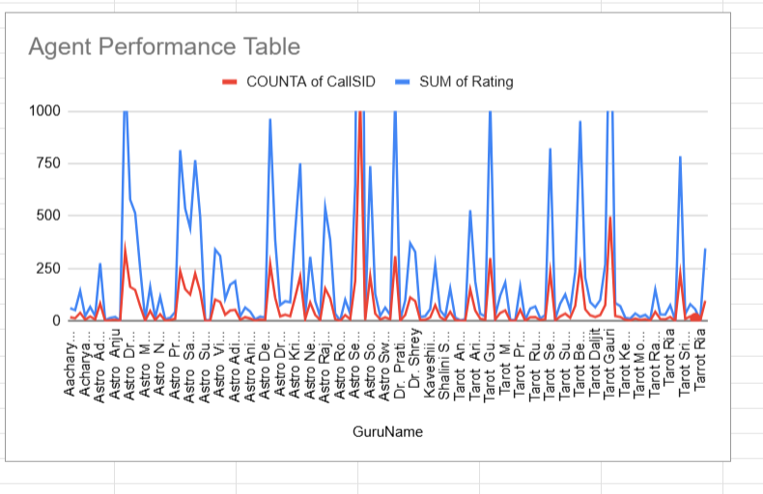
Insights:
Workload is not evenly distributed across agents
Some agents handle significantly more calls
Overloaded agents may experience:
- Lower performance
- Reduced customer satisfaction
Underutilized agents indicate inefficiency

Recommendations:
Even call distribution
Set workload threshold
Smart scheduling
Skill based routing to call- if the call duration is very high, assign the call to skilled agent
Monitor real time agent performance

Question 8: What new technologies or tools could be implemented to enhance call center operations and customer service?

Solution:

Approach:

To enhance call center operations and customer service,
the following technologies/tools can be helpfull:
- AI-powered Chatbots & Virtual Assistants
- Intelligent Call Routing Systems
- Real-Time Analytics Dashboards
- Speech Analytics & Sentiment Analysis Tools

Charts & Tables:
- Table / Chart Name:
<Name of the table or chart used (should align with Excel subsheet names) along with the screenshot of chart or table>
- Description:
<What the table or chart represents>

Insights:
Call volume shows peaks and variability → requires automation
Customer satisfaction is moderate → needs quality improvement tools
Workload is uneven → requires smart allocation
No strong correlation between duration & satisfaction → focus on quality, not time

Recommendations:
Leveraging AI-driven automation, intelligent routing, and real-time analytics, the call center can significantly improve efficiency, reduce workload imbalance, and enhance customer satisfaction.

Question 9: What metrics should be included in the final dashboard to comprehensively view call center performance and guide investment decisions?

Solution:

Approach:
Total Calls,Daily / Weekly Call Volume per agents
Customer satisfaction rating metrics for each agent
Opertaional efficiency - like total cost, call duration and call status
Calls Handled per Agent
Average Rating per Agent
Call Duration vs rating for each agents
Total Operational Cost
Call Duration
Call Status Distribution (Completed / Missed)
Total call counts
Call status for each agents
How many calls completed/failed/missed/busy

Charts & Tables:
Displays key metrics like total calls, average rating, and total cost - KPI Summary table
Call Volume Trend - Shows variable of call demand over time
Compares agents based on calls handled and ratings - Agent Performance charts
Displays proportion of completed vs missed calls - display call status distribution
Tracks changes in ratings over time -customer satisfaction rating trends

Insights:
Call volume fluctuates
Customer satisfaction is moderate → needs improvement
Agent performance varies → workload imbalance exists
Cost and efficiency need monitoring for optimization

Recommendations:
<Actionable recommendations based on the insights>

Question 10: How would you allocate a 1 crore rupee investment to optimize operational efficiency, enhance customer satisfaction, and boost profitability, and what analysis-based recommendations would you offer to support this?

[you have to give bullet pointers to answer this question]

Solution:

Approach:

If i have invest 1 cr rupee to optimizer the operational efficiency and enhance customer satisfaction, based on the data, i would invest more in training program and quality improvement rather than other areas

Agent Training & Quality Improvement- 40 percent of total amount
This will improve the
  - Communication skills for Agents
  - Faster issue resolution
  - Customer handling training

Smart Hiring- 25 percent of total amount
  - Hire agents for high-demand periods
  - Use flexible/shift-based staffing

Technology Upgrade- 20 percent of total amount
  - Implement AI based system for some area like chat bot system, virtual assistance based call system
  - Intelligent call routing system
  - Automation on few areas like monitoring and shifting the call where ever it is possible

Real-Time Monitoring & Dashboard- 10 Percent of total amount
  - Performance tracking tools
  - KPI dashboards for decision-making

Process Optimization- 5% of total amount
  - SOP improvements
  - Call flow redesign

Charts & Tables:
- Table / Chart Name:
<Name of the table or chart used (should align with Excel subsheet names) along with the screenshot of chart or table>
- Description:
<What the table or chart represents>

Insights:
<Key observations derived from the data>

Recommendations:
Prioritize training to improve customer satisfaction
Use data-driven hiring for peak periods
Implement automation tools to reduce workload
Balance workload across agents
Continuously monitor KPIs using dashboards

